How prometheus data connectd to Grafana Dashboard
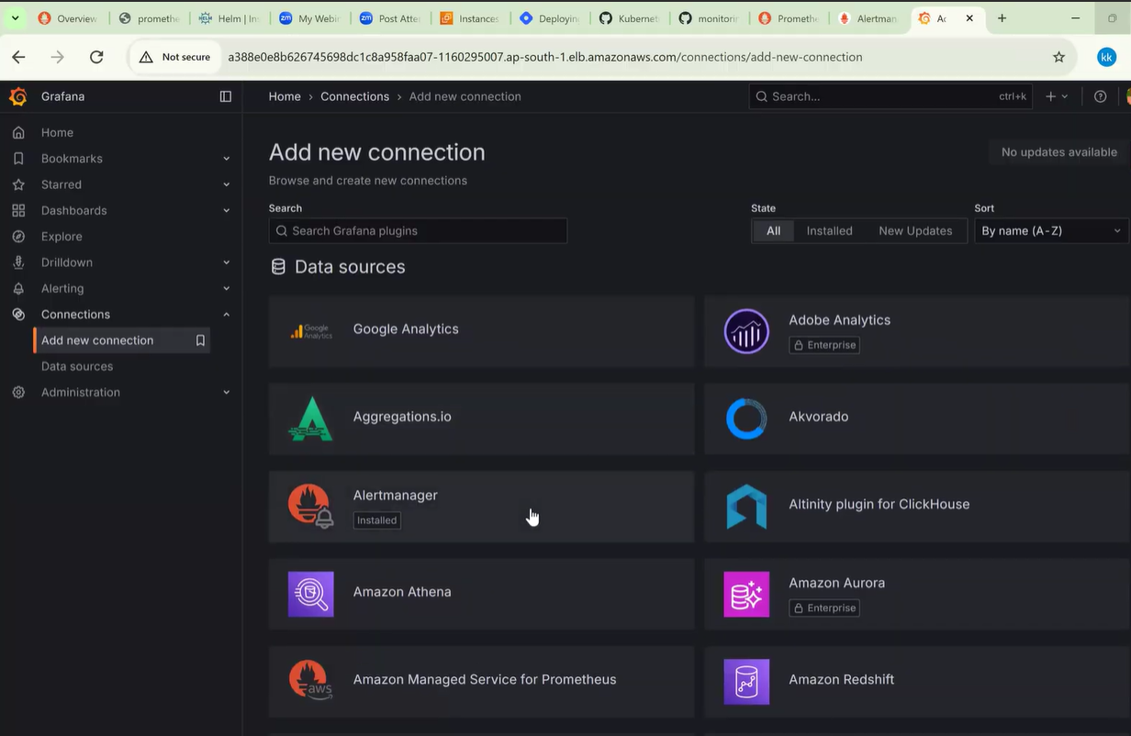
In Grafana Dashboard-----go to connections------click---Add new connection
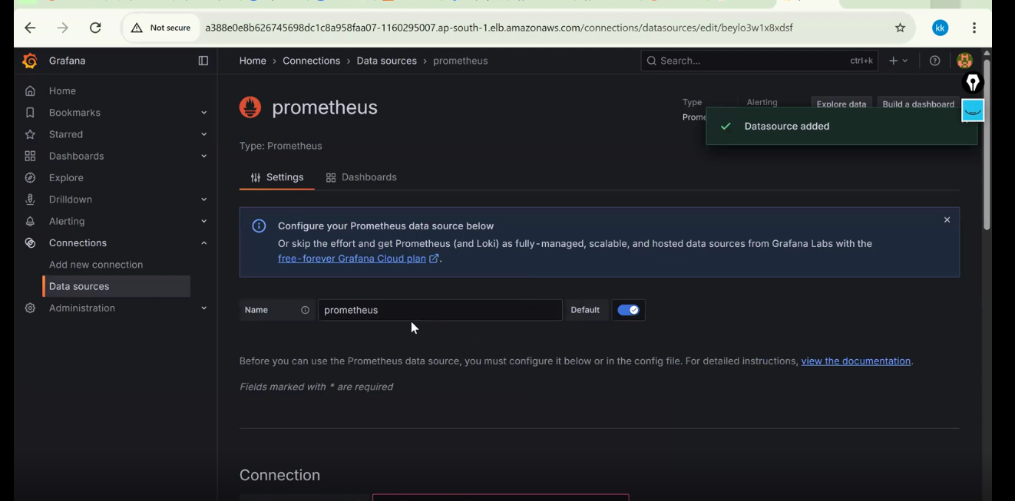
step-1: In Grafana Dashboard----go to Datasource & search for Prometheus

Click---save & next---------so connection is established for----Promethus server & Grafana
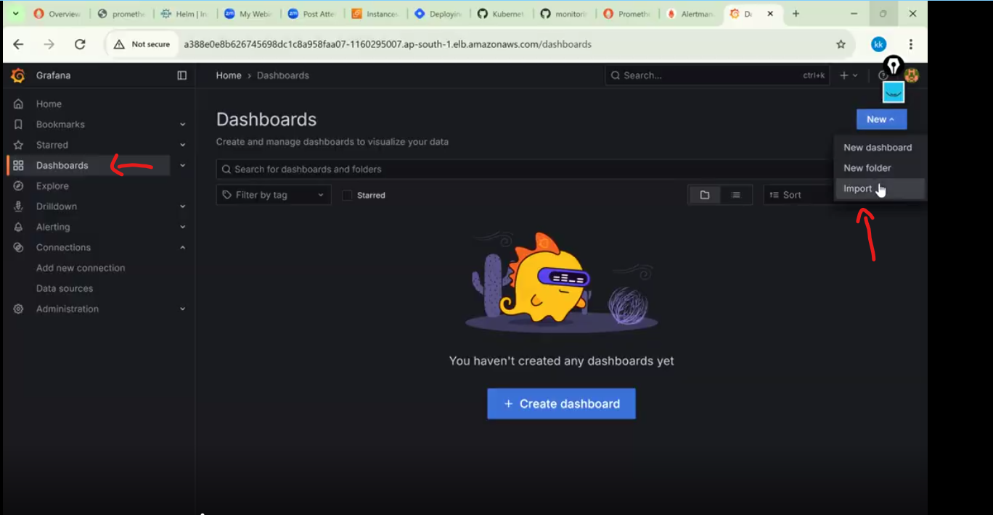
Step-2: Create Dashboard in Grafana:
Click—Dashboard ---click new---select any one of them----(New dashboard, New folder, Import)
_____________________________________________________
1️⃣ Service availability (Success rate %)
(
sum(rate(http_requests_total{status=~"2.."}[5m]))
/
sum(rate(http_requests_total[5m]))
) * 100
📌 Answers: Are users getting successful responses?

2️⃣ Error rate (5xx only)
sum(rate(http_requests_total{status=~"5.."}[5m]))
📌 Answers: Are users seeing server errors?

3️⃣ P95 latency (user-visible latency)
histogram_quantile(
0.95,
sum(rate(http_request_duration_seconds_bucket[5m])) by (le)
)
📌 Answers: Is the service slow for users?

4️⃣ Traffic (requests per second)
sum(rate(http_requests_total[5m]))
📌 Answers: Is traffic normal or spiking?

5️⃣ Error budget burn rate
1 -
(
sum(rate(http_requests_total{status=~"2.."}[5m]))
/
sum(rate(http_requests_total[5m]))
)
📌 Answers: How fast are we burning reliability?

6️⃣ Pod restart rate
sum(rate(kube_pod_container_status_restarts_total[5m]))
📌 Answers: Is the platform unstable?

7️⃣ CPU saturation (usage vs limit)
sum(rate(container_cpu_usage_seconds_total[5m]))
/
sum(kube_pod_container_resource_limits_cpu_cores)
📌 Answers: Are we hitting CPU limits?

8️⃣ Memory saturation
sum(container_memory_working_set_bytes)
/
sum(kube_pod_container_resource_limits_memory_bytes)
📌 Answers: Risk of OOM kills?

9️⃣ Instance availability (up)
sum(up == 1)
📌 Answers: How many targets are actually reachable?

🔟 Dependency latency (downstream service)
histogram_quantile(
0.95,
sum(rate(http_client_request_duration_seconds_bucket[5m])) by (le)
)
📌 Answers: Is a downstream dependency slowing us?
_______________________________________________________
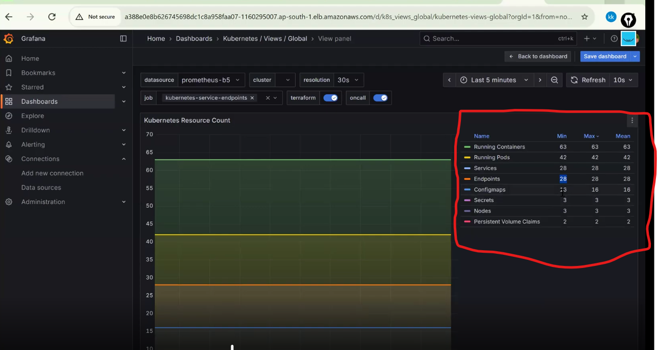
__________________________________
Cluster health:
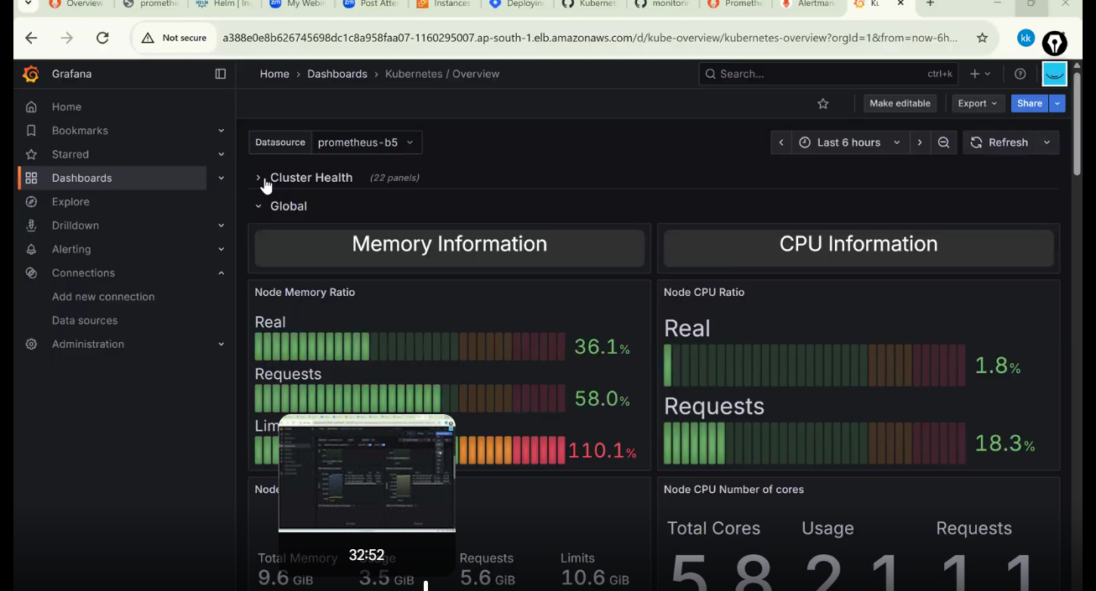
_________________
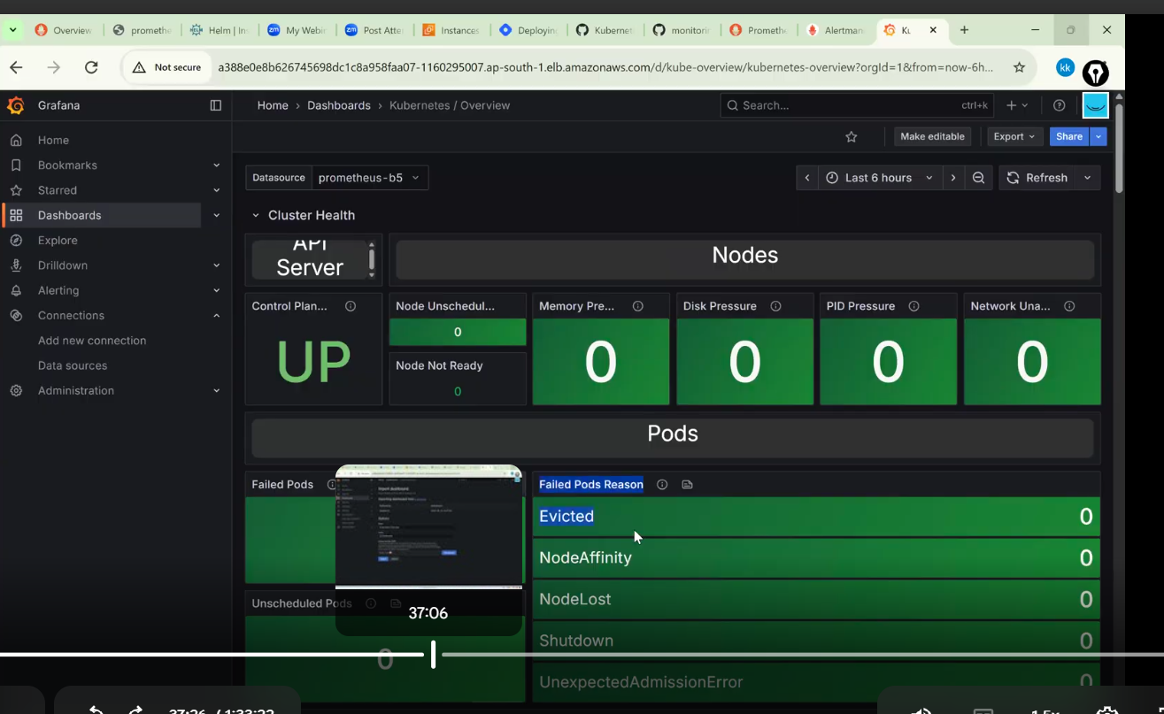
Autoenable every 15sec-------so it will refresh & update new data in every 15 sec------------
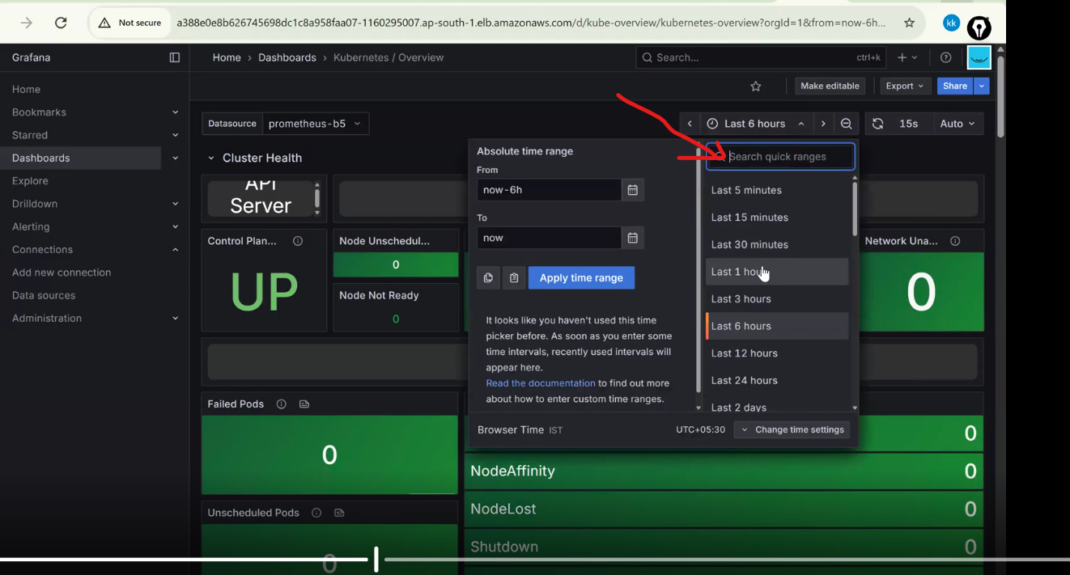
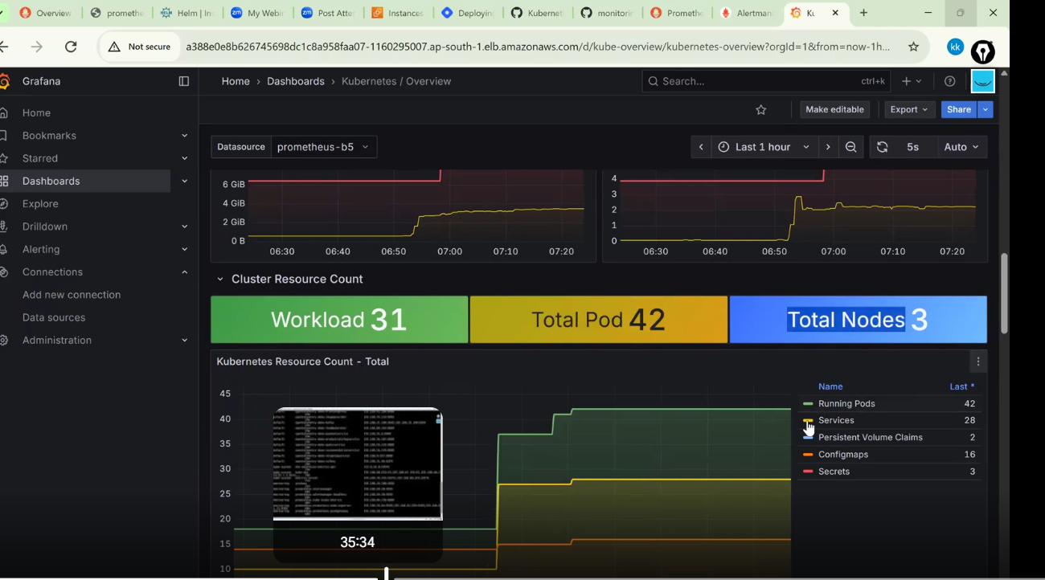
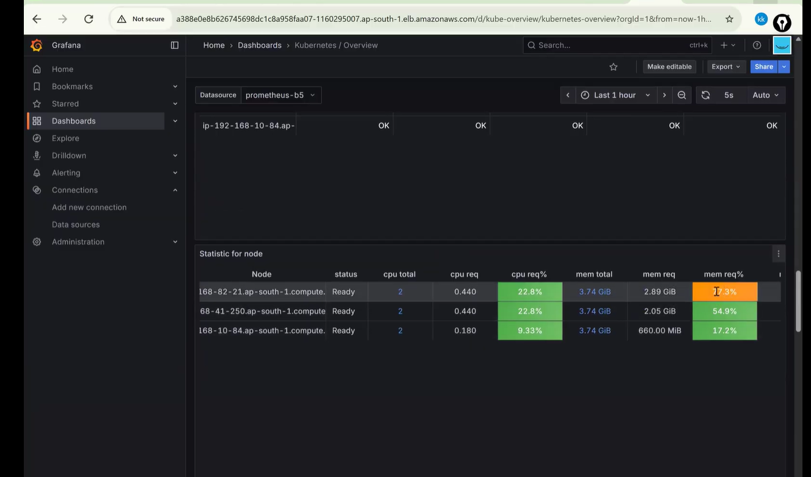
Want to create custom dashboard:
Dashboards creates through Grafana id or import json
_________________________________--
We have 3 options-----1.Create new dashboard
2.create new folder--------create dashoards under this folder
3.import
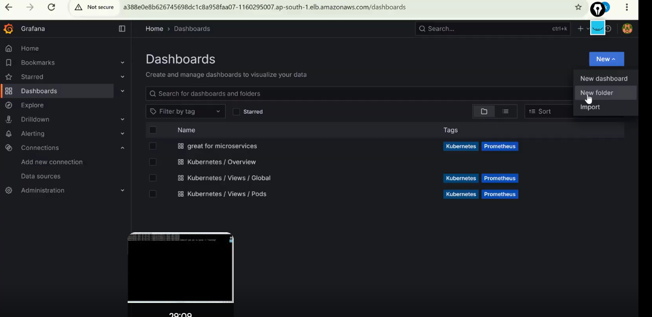
create new folder--------create dashoards under this folder
we udse this b/c we can split ----to monitor pods,
to monitor nodes etc
______________________________________________
create custom dashboard:
Click------new dashboard
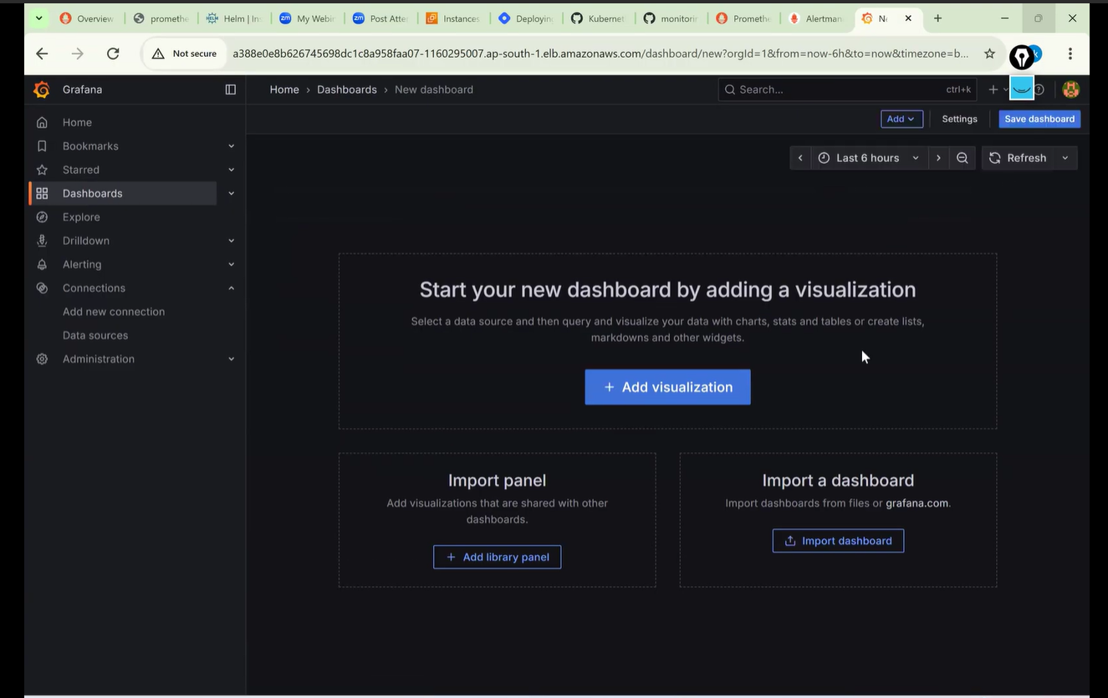
_____________________________________________________________________________
Click add visualisation:
Seslect data source-------prometheus
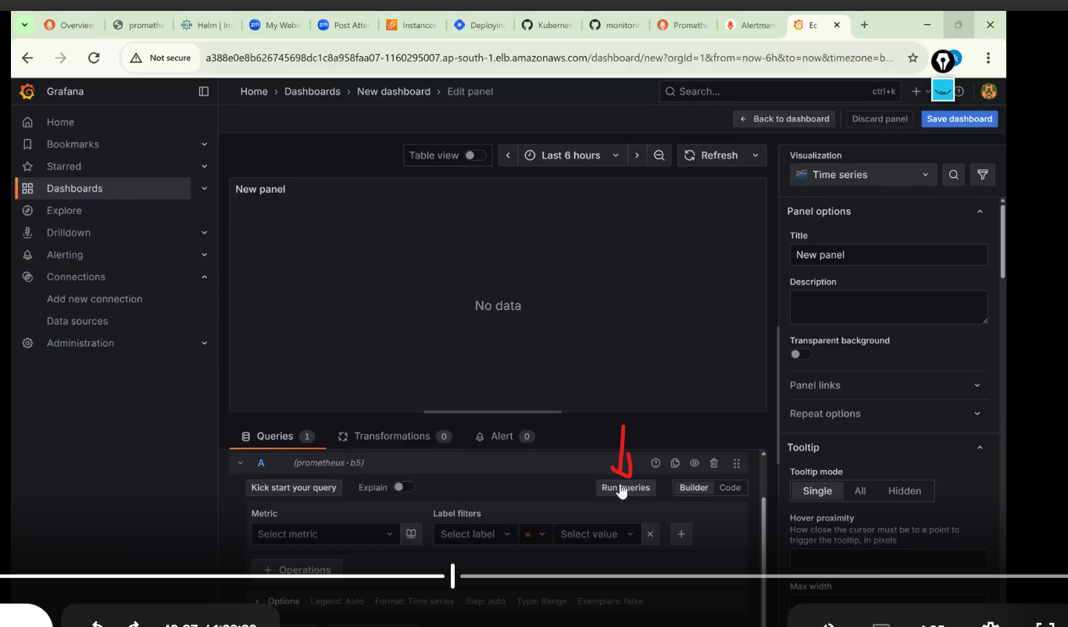now run the queries from here:
Click on --------code
___________
paste the querie & run queries
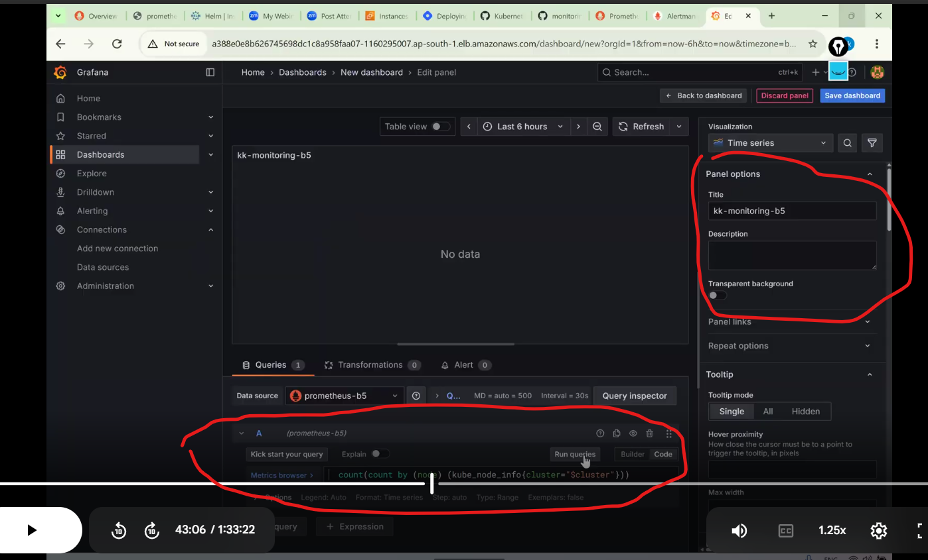
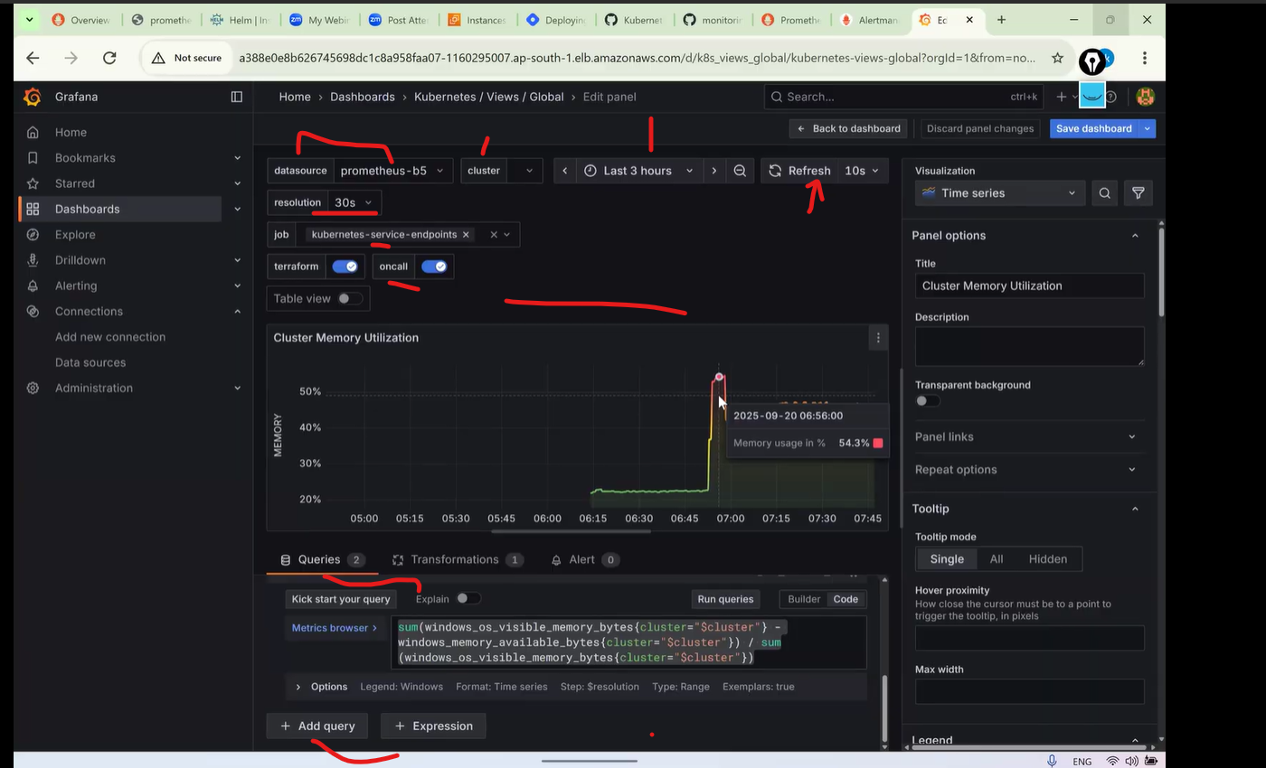
_____________________________________________________________________________
What query languages does Grafana support?
👉 Checks: Integration knowledge
Answer:
Grafana itself doesn’t have a query language; it uses the data source’s language like PromQL (Prometheus), LogQL (Loki), SQL, Lucene, etc.
________________________________________________________________________________----
How does Grafana work with Prometheus?
👉 Checks: Monitoring pipeline
Answer:
Prometheus scrapes metrics and stores time-series data. Grafana connects to Prometheus as a data source and uses PromQL queries to visualize metrics.
________________________________________________
What is alerting in Grafana?
👉 Checks: Ops readiness
Answer:
Alerting allows Grafana to evaluate queries periodically and trigger alerts when conditions are met (e.g., CPU > 80%).
- What alert states exist in Grafana?
👉 Checks: Alert lifecycle
Answer:
- OK
- Pending
- Alerting
- NoData
- Error

____________________________
What are recording rules and why do they matter for Grafana?
👉 Checks: Performance optimization
Answer:
Recording rules pre-compute expensive PromQL queries so Grafana dashboards load faster and reduce Prometheus load.
____________________________________________________----------
- What metrics do you usually visualize for Kubernetes in Grafana?
👉 Checks: Real-world experience
Answer:
- Node CPU / Memory
- Pod restarts
- Namespace resource usage
- API server latency
- etcd latency
- How do you visualize pod-level metrics in Grafana?
👉 Checks: PromQL skills
Answer:
Using metrics from kube-state-metrics and cAdvisor via Prometheus, filtered by namespace and pod labels.
- How do you build a dashboard from scratch in Grafana?
👉 Checks: Hands-on ability
Answer (Steps):
- Add data source
- Create dashboard
- Add variables
- Write queries
- Choose visualization
- Set thresholds
- Save & share

🔹 Scenario-Based (SRE / DevOps)
- Grafana dashboard is slow. How do you troubleshoot?
👉 Checks: Problem solving
Answer:
- Optimize PromQL
- Use recording rules
- Reduce panel refresh rate
- Limit time range
- Check Prometheus performance
- How do you version-control Grafana dashboards?
👉 Checks: Platform engineering
Answer:
Using JSON dashboards stored in Git and deployed via Terraform, Helm, or Grafana provisioning.

Alerting Rules and Recording Rules — exactly how interviewers and real projects expect them.

🔴 Alerting Rules (alerts.yml)
🚨 High CPU Usage
groups:
- name: node-alerts
rules:
- alert: HighCPUUsage
expr: avg(rate(node_cpu_seconds_total{mode!="idle"}[5m])) by (instance) > 0.8
for: 5m
labels:
severity: warning
annotations:
summary: "High CPU usage on {{ $labels.instance }}"
description: "CPU usage > 80% for 5 minutes"

🚨 High Memory Usage
- alert: HighMemoryUsage
expr: (node_memory_MemTotal_bytes - node_memory_MemAvailable_bytes)
/ node_memory_MemTotal_bytes > 0.85
for: 5m
labels:
severity: warning
annotations:
summary: "High memory usage on {{ $labels.instance }}"
description: "Memory usage > 85%"

🚨 Disk Space Low
- alert: DiskSpaceLow
expr: node_filesystem_avail_bytes{fstype!~"tmpfs|overlay"}
/ node_filesystem_size_bytes < 0.15
for: 10m
labels:
severity: critical
annotations:
summary: "Low disk space on {{ $labels.instance }}"
description: "Disk free < 15%"

🚨 Pod CrashLoop
- alert: PodCrashLooping
expr: rate(kube_pod_container_status_restarts_total[5m]) > 0
for: 3m
labels:
severity: critical
annotations:
summary: "Pod is restarting frequently"
description: "Pod {{ $labels.pod }} in namespace {{ $labels.namespace }} is crashing"

🚨 API High Latency (Histogram)
- alert: HighAPILatency
expr: histogram_quantile(0.95, rate(http_request_duration_seconds_bucket[5m])) > 1
for: 5m
labels:
severity: critical
annotations:
summary: "High API latency"
description: "95th percentile latency > 1s"

🟢 Recording Rules (recording_rules.yml)
👉 Used to precompute metrics for performance + faster Grafana dashboards.
CPU Usage Precompute
groups:
- name: node-recording
rules:
- record: instance:cpu_usage:rate5m
expr: avg(rate(node_cpu_seconds_total{mode!="idle"}[5m])) by (instance)

Memory Usage Precompute
- record: instance:memory_usage:ratio
expr: (node_memory_MemTotal_bytes - node_memory_MemAvailable_bytes)
/ node_memory_MemTotal_bytes

API Request Rate
- record: service:http_requests:rate5m
expr: sum(rate(http_requests_total[5m])) by (service)

Error Rate
- record: service:http_errors:rate5m
expr: sum(rate(http_requests_total{status=~"5.."}[5m])) by (service)

📁 How to Load Rules in Prometheus
rule_files:
- "alerts/*.yml"
- "recording/*.yml"

🧠 Interview One-Liners
Use these in interviews:
✅ Alerting rule:
“Defines conditions to trigger incidents.”
✅ Recording rule:
“Precomputes expensive queries to improve performance and reduce Prometheus load.”
✅ Golden line:
“Alerting rules are for humans, recording rules are for systems.”

